Software Testing Question 2

The types of coverage we are going to consider in the following section are:
Statement coverage: All statements have been executed by at least one test.
Branch coverage: All combinations in branches have been executed at least once.
Path coverage: All loops are iterated zero (where possible), once and many times (> 1).

We achieved 100% statement coverage of the toRelativeURL method in task 1 (see fig. 1).

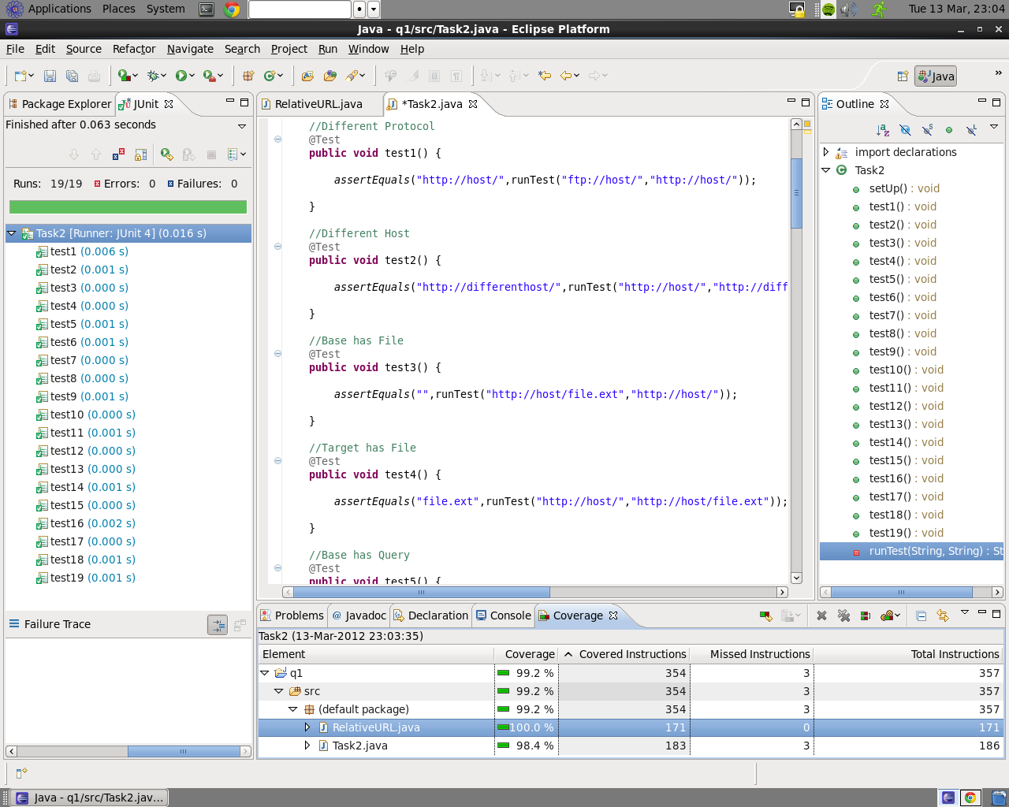
Figure 1 - the test numbers correspond to the tests in task 1

Despite having 100% statement coverage, we still need to ensure the effectiveness of our test by investigating other methods of coverage. Through eclemma we can check branch coverage which, in our case, is also 100%.

Statement coverage is generally viewed as a poor indication of correctness and coverage of the flow of control in systems. This is why we don’t restrict ourselves to one coverage metric when analysing with testing suites. We also considered branch coverage in an attempt to guarantee the effectiveness of our test suite. We were not content with only statement and branch coverage as we felt there could be untested situations for which the method may fault resulting in a failure. The core parts of this method contain loops which we feel may not have been adequately validated using statement and branch coverage, therefore we made the decision to test path coverage.

In order to test our path coverage of loops in this method, we used scaffolding to count the number of iterations of a loop. Before a loop we defined an integer and instantiated it to zero. At the beginning of the loop (the line directly after the loop statement) we iterated the counter. We surrounded the loop with a ‘try’ statement and used ‘finally’ containing a print statement, to ensure we always displayed the number of iterations (this executes regardless of whether the method returns during the try statement).

We identified 5 while loops in the method. After applying the scaffolding described above to all the loops we discovered our tests covered all paths for 4 of the loops but excluded the ‘many times’ case for one. We have inserted another test, ‘task2Test1’, and validated it. With this inclusion we have full path coverage (where possible) as there are several ‘while(true)’ loops which will never be taken zero times.

